BOW ARM LEAFLET

Bow-arms consist of a D-shaped bracket and a sliding internal section which enables the motorisation of canopy doors, without the need for the door to be upgraded to retractable gear.
The bow-arm works by replicating the natural arc of the door when manually operated, and comes complete with all the gear required to mount it to an existing motor.
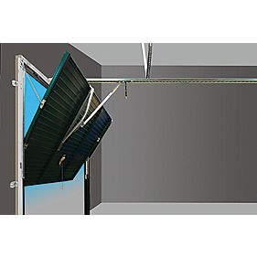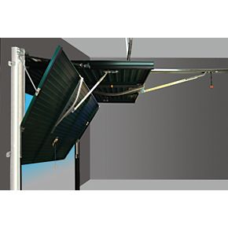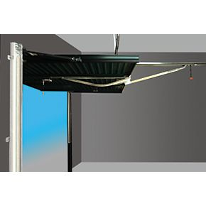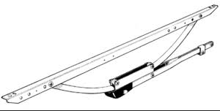

NOTE: For the bow-arm to function effectively the garage door needs to be freely operating under normal conditions, have a reasonably strong door panel and the motor needs to have at least 700N power and adjustable sensitivity. The bow-arm will reduce drive through height by a maximum of 6”.

